**AtliQ Hospitality Revenue Dashboard**

📌 Project Overview

This project is part of Challenge #1: **Provide Insights to the Revenue Team in the** **Hospitality Domain**. The objective is to analyze historical hotel performance data for AtliQ Grands, a five-star hospitality chain operating across multiple cities in India, and deliver actionable revenue insights using **Business Intelligence and Data Analytics.**

AtliQ Grands has been experiencing a decline in market share and revenue due to increased competition and ineffective decision-making. As the organization does not have an in-house analytics team, this dashboard is designed to support the **revenue management team** with data-driven insights to improve performance.

💼 Business Problem Statement

* AtliQ Grands owns multiple luxury and business hotels across India
* Facing revenue and market share loss in the luxury & business hotel segment
* Needs analytical insights to support strategic decisions
* Historical data is available, but insights are not easily accessible

**Goal**: Leverage data analytics and visualization to: - Track key revenue and operational metrics - Identify trends and underperforming areas - Enable informed revenue optimization decisions

🎯Project Objectives

1. Create key hospitality metrics as per the provided metric list
2. Design a dashboard aligned with the stakeholder-provided mock-up
3. Generate additional insights beyond the predefined metrics

## 📊Dashboard Highlights

The dashboard provides a comprehensive view of hotel performance across cities, room classes, booking platforms, and time.

## 🔑 Key Metrics

* Revenue
* RevPAR (Revenue per Available Room)
* Occupancy %
* ADR (Average Daily Rate)
* DSRN (Daily Sellable Room Nights)
* DBRN (Daily Booked Room Nights)
* DURN (Daily Utilized Room Nights)
* Realisation %
* Cancellation %
* Average Rating

## **📈**Key Visuals & Analysis

* Revenue, RevPAR & Occupancy Trends (Weekly)
* Revenue Split by Category (Luxury vs Business)
* ADR & Realisation % by Booking Platform
* Weekday vs Weekend Performance Comparison
* Property-level Performance Table with conditional formatting

# 🧠 Insights Generated

* Occupancy and RevPAR show noticeable weekday vs weekend variation
* Luxury category contributes a higher percentage of total revenue
* Certain booking platforms have lower realisation due to higher cancellations
* Some properties show strong occupancy but lower ADR, indicating pricing optimization opportunities
* Average ratings correlate with better realisation and occupancy in select properties

**🛠️**Tools & Technologies Used

* **Power BI** – Data modelling & dashboard creation
* **Power Query** – Data transformation
* **DAX** – Calculated measures and KPIs
* **Excel / CSV** – Source data format

📂Dataset Information

* Mock hospitality dataset provided as part of the challenge
* Contains booking, revenue, room, property, and customer-related attributes
* Time period covers multiple weeks and months for trend analysis

📊 Dashboard Preview

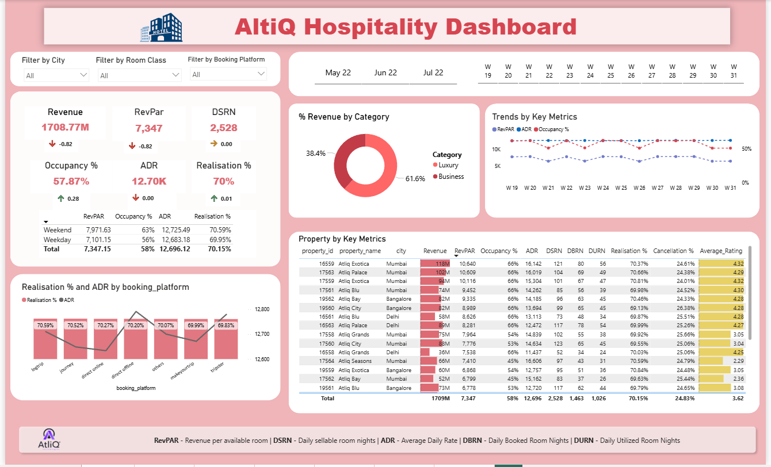

❓How to Use

1. Download the **.pbix file** from the repository.
2. Open using **Power BI Desktop**
3. Use slicers to filter by:
   * + City
     + Room Class
     + Booking Platform
     + Date / Week
4. Explore insights to support revenue decisions.

📌Key Learnings

* Applied domain knowledge in hospitality analytics
* Built stakeholder-aligned dashboards
* Translated raw data into actionable insights
* Improved proficiency in Power BI, DAX, and data storytelling

📖 Reference

* Channel Name : codebasics
* Link to the Project : [https://www.youtube.com/watch?v=4QkYy1wANXA](https://www.youtube.com/watch?v=tT4V7zguCnc&t=33s)